**Twitter Sentiment Anal**

Submitted in partial fulfillment of the requirements of the degree

**BACHELOR OF ENGINEERING** IN **COMPUTER ENGINEERING**

By

**Chinmay Mule Roll No. 08**

**Saurabh Shivgan Roll No. 35**

**Sushant Wadekar Roll No. 39**

**Sudarshan Mahendrakar Roll No. 03**

Supervisor

**Prof.**  Pratap Nair



**Department of Computer Engineering**

**K.C. College of Engineering & Management Studies and Research , Thane (E)**University of Mumbai

(AY 2021-22)

# CERTIFICATE

This is to certify that the Mini Project entitled **“Twitter Sentiment Analysis”** is a bonafide work of **Chinmay Mule Roll No. 08, Saurabh Shivgan Roll No. 35, Sushant Wadekar Roll No. 39, Sudarshan Mahendrakar Roll No. 03** submitted to the University of Mumbai in partial fulfillment of the requirement for the award of the degree of **“Bachelor of Engineering”** in **“Computer Engineering” .**

## (Prof. Pratap Nair)

Supervisor

## (Prof.Mandar Ganjapurkar) (Prof.Dr. Vilas Nitnaware )

Head of Department Principal

# Mini Project Approval

This Mini Project entitled “**Twitter Sentiment Analysis”** by **Chinmay Mule Roll No. 08, Saurabh Shivgan Roll No. 35, Sushant Wadekar Roll No. 39, Sudarshan Mahendrakar Roll No. 03** is approved for the degree of **Bachelor of Engineering** in **Computer Engineering.**

**Examiners**

**1………………………………………**

(Internal Examiner Name & Sign)

## 2…………………………………………

(External Examiner name & Sign)

Date: Place:

# Contents

## Abstract ii

## Acknowledgments iii

## List of Abbreviations iv

## List of Figures v

## List of Tables vi

## List of Symbols vii

## Introduction 1

* 1. Introduction
  2. Motivation
  3. Problem Statement & Objectives
  4. Organization of the Report

1. **Literature Survey 11**
   1. Survey of Existing System
   2. Limitation Existing system or research gap
   3. Mini Project Contribution

## Proposed System (eg New Approach of Data Summarization ) 18

* 1. Introduction
  2. Architecture/ Framework
  3. Algorithm and Process Design
  4. Details of Hardware & Software
  5. Code
  6. Experiment and Results
  7. Conclusion and Future work.

## References 32

**Abstract**

In this project, we were asked to collect papers, to explore how machine learning algorithms can be used to find the patterns in data. We were expected to gain knowledge about leaf diseases, their prevention by exploring the research papers, and were expected to submit a report about it and the expected algorithms. After performing the required tasks, herein lies our final report.

**Acknowledgement**

We would like to express special thanks of gratitude to our guide Dr. Ravi Prakash who

gave us the golden opportunity to do this wonderful project on the topic of ‘**Twitter Sentiment Analysis**’, which also helped us in doing a lot of research and we came to know about so many new things. We would also like to thank our principal Dr. Vilas Nitnaware

for providing us the opportunity to implement our project. We are really thankful to them. Finally

we would also like to thank our parents and friends who helped us a lot in finalizing this project

within the limited time frame.

(Name of student and Roll No.)

1. (Roll No.: 08) Chinmay Mule

2. (Roll No.: 35) Saurabh Shivgan

3. (Roll No.: 39) Sushant Wadekar

4. (Roll No.: 03) Sudarshan Mahendrakar

**List of Figures**

| **Sr. No.** | **Figure No.** | **Name** |
| --- | --- | --- |
| 1. | 3.6.1 | Output 1 |
| 2. | 3.6.2 | Output 2 |
| 3. | 3.6.3 | Output 3 |
| 4. | 3.6.4 | Output 4 |

**Introduction**

* 1. **Introduction**

Sentiment analysis refers to identifying as well as classifying the sentiments that are expressed in the text source. Tweets are often useful in generating a vast amount of sentiment data upon analysis. These data are useful in understanding the opinion of the people about a variety of topics. Therefore we need to develop an **Automated Machine Learning Sentiment Analysis Model**in order to compute the customer perception.

**1.2 Motivation**

In the marketing field companies use it to develop their strategies, to understand customers’ feelings towards products or brands, how people respond to their campaigns or product launches and why consumers don’t buy some products. Sentiment analysis also is used to monitor and analyze social phenomena, for the spotting of potentially dangerous situations and determining the general mood of the blogosphere.

**1.3 Problem Statement**

In this project, we try to implement a Twitter sentiment analysis model that helps to overcome the challenges of identifying the sentiments of the tweets. With the help of analysis of sentiments from the tweets via this model, people can help improve brand perceptions, get honest customer feedback and improve the customer service of their organization.

**2. Literature Survey**

# Twitter sentiment analysis: <https://ieeexplore.ieee.org/document/7066632>

# Sentiment Analysis Using Naive Bayes Algorithm Of The Data Crawler: Twitter

<https://ieeexplore.ieee.org/document/>8985884

## Proposed System (eg New Approach of Data Summarization )

Introduction

Sentiment analysis refers to identifying as well as classifying the sentiments that are expressed in the text source. Tweets are often useful in generating a vast amount of sentiment data upon analysis. These data are useful in understanding the opinion of the people about a variety of topics. Therefore we need to develop an **Automated Machine Learning Sentiment Analysis Model**in order to compute the customer perception.

**Algorithm and Process Design:**

In this project we have used Textblob to calculate subjectivity and objectivity of a particular tweet, which helps us to plot the graph and understand the tweet with a greater perspective.

**Details of Hardware & Software**

* Tools/Softwares used :

a) Jupyter Notebook (Anaconda)

* Python Modules used:

a) Tweepy

b) Pandas

c) TextBlob

**Code**

from turtle import textinput

import tweepy

import configparser

import pandas as pd

import re

from textblob import TextBlob

import matplotlib.pyplot as plt

import streamlit as st

def cleantt(tw):

tw = re.sub('#bitcoin','bitcoin',tw)

tw = re.sub('#Bitcoin','Bitcoin',tw)

tw = re.sub('#[A-Za-z0-9]+', '', tw)

tw = re.sub('\\n', '',tw)

tw = re.sub('https?:\/\/\S+','',tw)

tw = re.sub('[@#]','',tw)

return tw

def re_emotions(tw):

#text = u'This dog \U0001f602'

#print(text) # with emoji

emoji_pattern = re.compile("["

u"\U0001F600-\U0001F64F" # emoticons

u"\U0001F300-\U0001F5FF" # symbols & pictographs

u"\U0001F680-\U0001F6FF" # transport & map symbols

u"\U0001F1E0-\U0001F1FF" # flags (iOS)

"]+", flags=re.UNICODE)

print(emoji_pattern.sub(r'', tw)) # no emoji

#import re

#re_emotions()

def subjectivity(tw):

return TextBlob(tw).sentiment.subjectivity

def polarity(tw):

return TextBlob(tw).sentiment.polarity

def Gsentiment(score):

if score < 0:

return 'Negative'

elif score == 0:

return 'Neutral'

else:

return 'Positive'

st.title('Twitter sentimental Analysis')

usr_inp = st.text_input('Enter a hastag','#Bitcoin')

global use_inp

num = st.number_input('Enter a number',value = 50, max_value=1000, min_value=1)

st.write('You Have Entered:', usr_inp)

clicked = st.button("Submit")

if clicked:

config = configparser.ConfigParser()

config.read('config.ini')

api_key = config['twitter']['api_key']

api_key_secret = config['twitter']['api_key_secret']

access_token = config['twitter']['access_token']

access_token_secret = config['twitter']['access_token_secret']

auth = tweepy.OAuthHandler(api_key,api_key_secret)

auth.set_access_token(access_token,access_token_secret)

api = tweepy.API(auth, wait_on_rate_limit=True)

print('Auth done')

#HERE CHANGE NUMBER .ITEMS(NUMBER) MAX = 1000 MIN = 10

#MAKE CHANGES IN SEARCH_QUERY TO CUSTOMIZE THE INPUT

search_query = str(usr_inp) + '-filter:retweets'

tweets = tweepy.Cursor(api.search_tweets, q=search_query, lang='en', tweet_mode='extended').items(num)

all_tweets = [tweet.full_text for tweet in tweets]

df = pd.DataFrame(all_tweets,columns=['Tweets'])

df['Cleaned_Tweets'] = df['Tweets'].apply(cleantt)

df['Cleaned_Tweets_emoji'] = df['Tweets'].apply(re_emotions)

df['Subjectivity'] = df['Cleaned_Tweets'].apply(subjectivity)

df['Polarity'] = df['Cleaned_Tweets'].apply(polarity)

df['Sentiment'] = df['Polarity'].apply(Gsentiment)

print(df)

st.subheader('Figures')

fig = plt.figure(figsize=(8,6))

for i in range(0,df.shape[0]):

plt.scatter(df['Polarity'][i],df['Subjectivity'][i],color='Red')

plt.title('Analysis')

plt.xlabel('Polarity')

plt.ylabel('Subjectivity')

st.pyplot(fig)

st.subheader('Figures #2')

fig1 = plt.figure(figsize=(8,6))

df['Sentiment'].value_counts().plot(kind='bar')

plt.title('Analysis')

plt.xlabel('Sentiment')

plt.ylabel('Count')

st.pyplot(fig1)

Experiment and Results

3.6.1

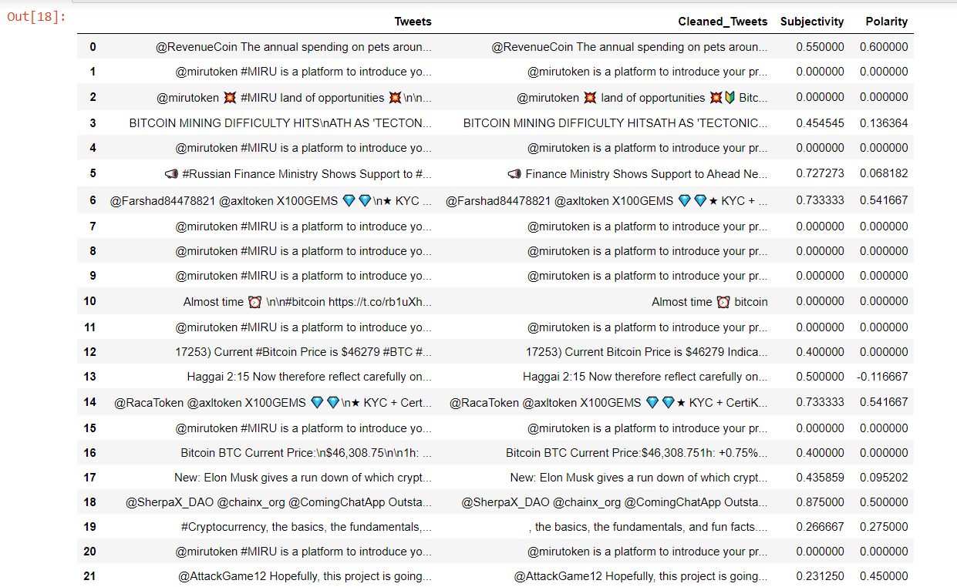

3.6.2

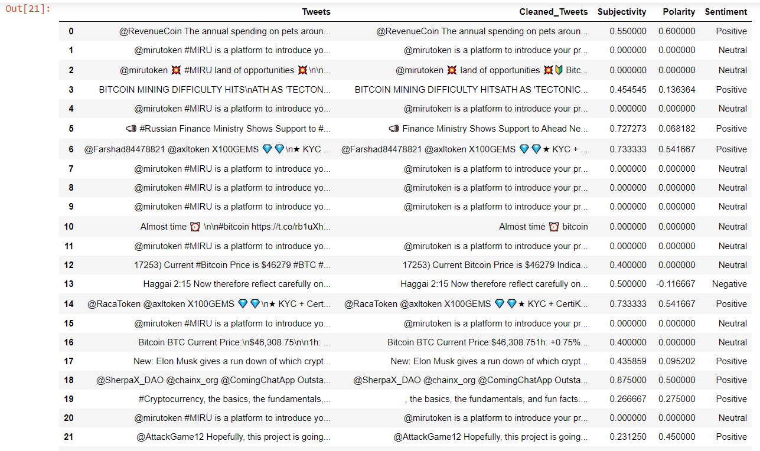

3.6.3

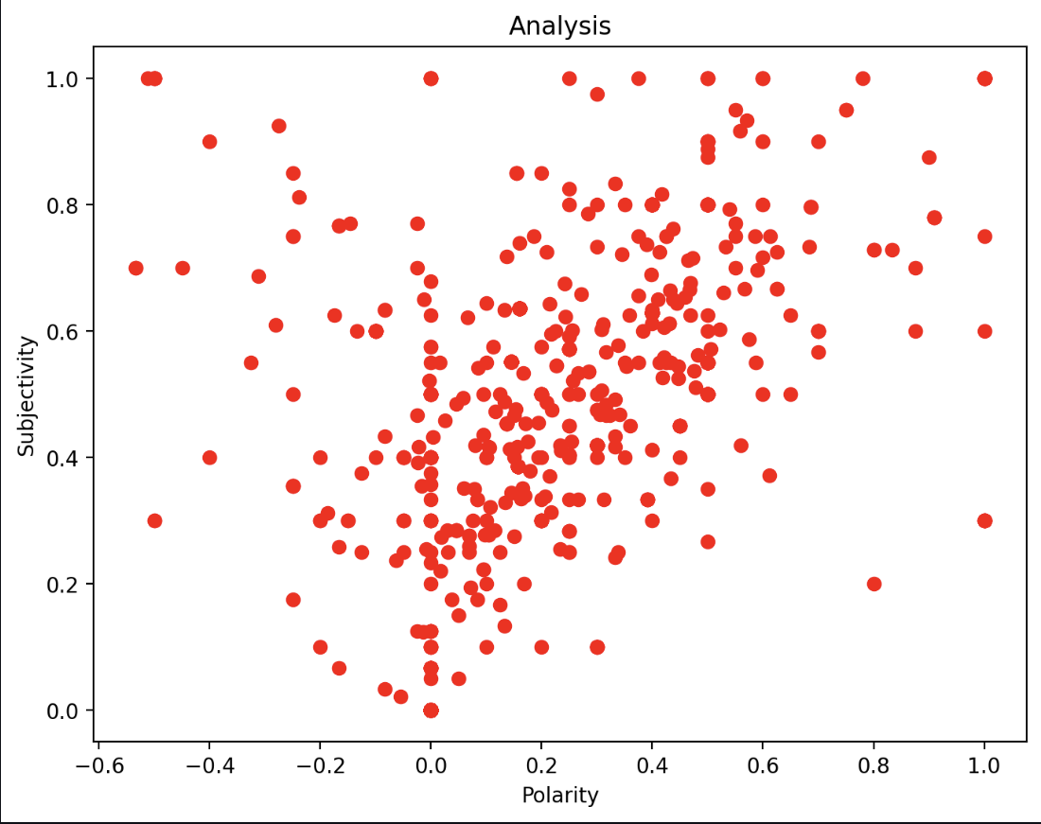

3.6.4

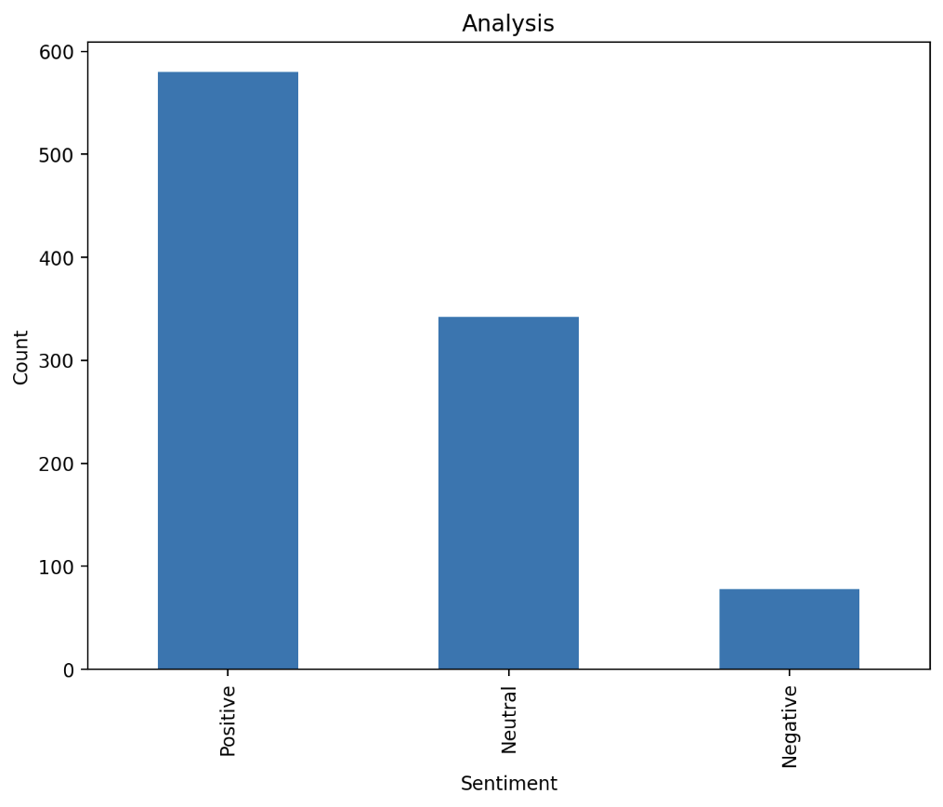

Conclusion and Future work.

Twitter is full of useful data that can be easily extracted for your organization’s benefit. Once you’ve generated insights through analysis, you’ll better understand your brand, grow your online influence, and improve your product. We can conclude that the cleaner the data, more accurate results can be obtained.

**References-**

1. <https://www.analyticsvidhya.com/blog/2021/06/twitter-sentiment-analysis-a-nlp-use-case-for-beginners/#:~:text=Sentiment%20analysis%20refers%20to%20identifying,about%20a%20variety%20of%20topics>.
2. <https://www.geeksforgeeks.org/twitter-sentiment-analysis-using-python/>
3. https://developer.twitter.com/en/docs/tutorials/how-to-analyze-the-sentiment-of-your-own-tweets